TEK306 Sikkerhet i mobile applikasjoner
Assignment 2 (Arbeidskrav, last edited 17.10.22)

Contents
Formalities: 1
Case: Reflective essay on security in a selected mobile application using an online mobile app penetration testing platform, i.e., ImmuniWeb. 2
The report 6
General guide 6

Formalities:
- The goal of this assignment is to explore security issues in a selected mobile application and write a reflective report.
- The assignment can be carried out in groups of 7± 2 members, and it should be made clear who has worked in the group by writing the names of each participant on the first page of the report.
- The report should be delivered through Canvas in pdf or word format.
- The assignment’s duration is from 17.10.2022 (start date) to 14.11.2022(due date).

Case: Reflective essay on security in a selected mobile application using an online mobile app penetration testing platform, i.e., ImmuniWeb.

The ImmuniWeb Platform helps to test, secure, and protect mobile applications to prevent supply chain attacks and data breaches and to comply with regulatory requirements. This assignment aims to explore security issues in a selected mobile application. Based on the explored security flaws and weaknesses that may impact the application, write a report on the prevention mechanisms which can be adapted to your mobile application to protect itself from different security attacks, to ensure data privacy, to guaranty safe external API communication. Note: You’re not required to register/login. So, please use only the part of the reports you see on the screen (without pressing the SHOW or LEARN MORE buttons).

Procedure to do penetration testing:
Step 1: Go to https://www.immuniweb.com/mobile/
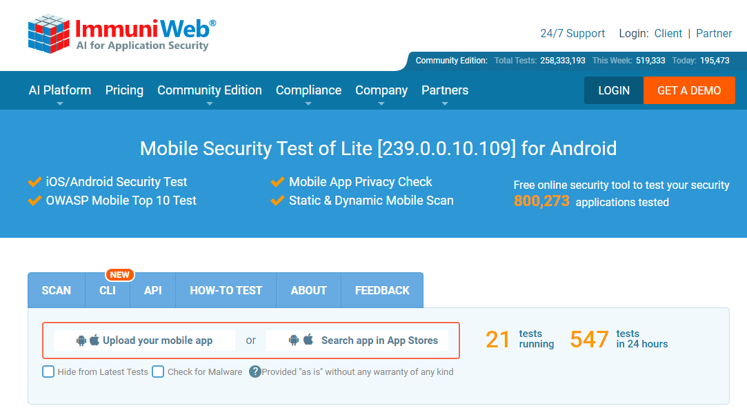

Step 2: Select a mobile app based on your own preference. For instance, you selected “CANVAS” app for penetration testing to explore security issues.

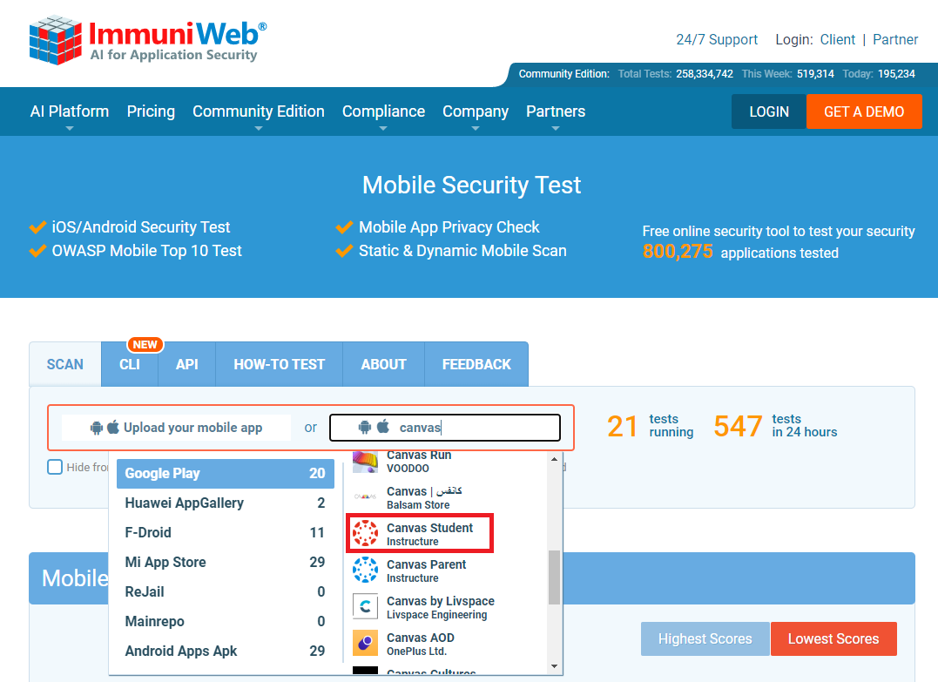

Step 3: ImmuniWeb will generate a penetration testing report (i.e., Summary of Mobile Application Security Test) based on your selected app, consisting of Mobile App Permissions and Privacy, OWASP Mobile Top 10 Security Test, Mobile App External Communications, and Software Composition Analysis aspects.
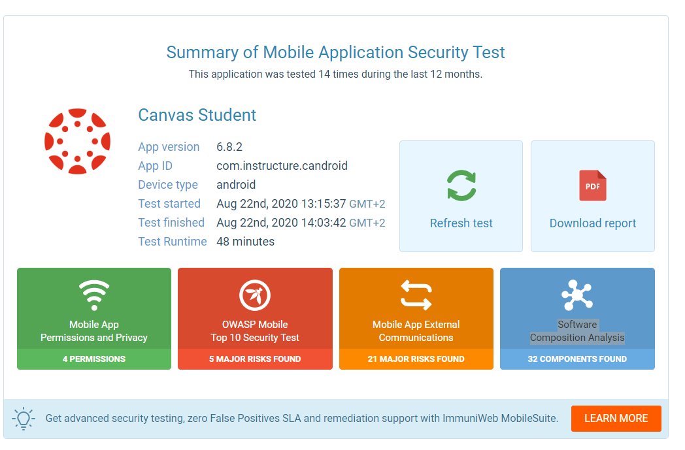
Step 4: You need to go through each of the aspects, e.g., Mobile App Permissions and Privacy. In each aspect you will find different vulnerabilities, weakness, risks. 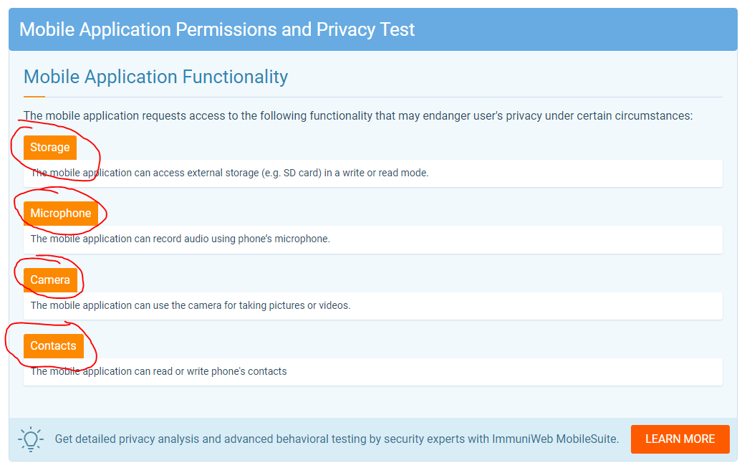

Step 5: After identifying each issue, try to find preventive solutions by doing literature review and include those prevention measures in your reflective report.
Follow the step 4 and 5 for all the aspects, i.e., Mobile App Permissions and Privacy, OWASP Mobile Top 10 Security Test, Mobile App External Communications, and Software Composition Analysis.

The report
Your final submission is expected to be structured as below and the questions you need to keep in mind while you are writing are stated in parentheses:
- Introduction
This section should give answers to the following questions. What are you going to write about (e.g., Android)? What makes your chosen case interesting?
- Penetration Testing Report
You can copy and paste the report from ImmuniWeb directly here.
- Preventive Measures
This section is the heart of the report. You need to find out resolutions for different security issues that you found in penetration testing report. Thus, all the prevention measures should be described here.
- Conclusion
This section is where you write your overall reflection on security issues concerning the selected mobile application and provide concluding text by addressing a few key issues relating to the context of the assignment.
- References
Here, you should list at least 3 articles and make sure that all the listed articles are appropriately cited. In addition, you should use either Chicago, Harvard or AP as your referencing style.

General guide
The length of the report should be 1250-2000 words excluding the title, outline, and references pages.

